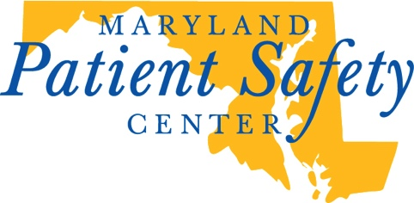

News Release

For Immediate Release: November 23, 2015
Contact: Linda Harder, The Maryland Patient Safety Center, lharder@nevinspr.com 443-762-5569
Maryland First to Achieve Recognition for all Birthing Hospitals
March of Dimes applauds state for avoiding early elective deliveries

Baltimore, MD – The Maryland Patient Safety Center (Center), working with the Maryland Department of Health and Mental Hygiene, announced that its efforts to prevent unnecessary early elective deliveries have paid off for Maryland mothers and infants. The Center recently was notified by the March of Dimes that the state was the first in the country to have 100 percent of its birthing hospitals achieve recognition for their work to reduce the rate of early elective deliveries to less than five percent for six consecutive months.

Robert Imhoff, President & CEO of the Center, said, “We’re thrilled that our efforts to meet this important safety goal have been so successful. Having an elective delivery before 39 weeks gestational age increases the risk for complications for both mother and baby. Getting the rate lower than five percent for every single hospital in the state is a real achievement, especially when compared to the national average of 10 to 20 percent, according to the American Congress of Obstetricians and Gynecologists.”

Since 2009, the Maryland Patient Safety Center has worked with Health and Mental Hygiene, the Maryland Hospital Association and Maryland hospitals to reduce early elective caesarean sections (C-sections) or inductions without medical reasons. Deliveries that occur after 39 weeks, when fetal development is complete, significantly reduces the risk of breathing and feeding problems, low blood sugar, jaundice and other problems for the newborn.

“This is about keeping babies and moms safe,” noted Health and Mental Hygiene Secretary Van T. Mitchell. “This achievement requires structural and policy changes, as well as making sure that the policies are enforced at each and every hospital. Without a concerted focus on this issue by the Center, Health and Mental Hygiene staff, and hospitals and their physicians, this would not have been possible.”

Tina Cavucci, Chapter Director of the March of Dimes Maryland-National Capital Area, added, “Our goal is to have as many healthy babies born as possible. We applaud the Maryland Patient Safety Center and its partners for making Maryland one of the safest states for babies in the country.”

Imhoff noted that the Center’s next initiative to keep mothers and babies safe is to decrease the rate of first-time caesarean sections. Some 90 percent of mothers whose first child is born via C-section have subsequent C-sections.

About the Maryland Patient Safety Center
The Center is recognized as a national leader in patient safety. As a center of patient safety innovations, it convenes care providers to accelerate understanding and to implement evidence-based solutions for preventing avoidable harm. Visit http://www.marylandpatientsafety.org/ for more.

# # #

